 | Course Name: Advanced Web Technology | EXPERIMENT NO. 9
 | Course Code: 20CP314P  Faculty: Komal Singh | Branch: CSE
 | Course Code: 20CP314P  Faculty: Komal Singh | Semester: VI
Submitted by: Harsh Shah
Roll no: 21BCP359

Objective: Working with React hooks
- Write react programs displaying the usage of each of the below given react hooks:
- useReducer

UseReducer.jsx
import { useReducer } from "react";
import { ACTION_TYPES } from "./postActionTypes";
import { INITIAL_STATE, postReducer } from "./postReducer";

const Post = () => {
const [state, dispatch] = useReducer(postReducer, INITIAL_STATE);

const handleFetch = () => {
dispatch({ type: ACTION_TYPES.FETCH_START });
fetch("https://randomuser.me/api/")
.then((res) => {
return res.json();
})
.then((data) => {
const firstName = data.results[0].name.first;
const lastName = data.results[0].name.last;

const greet = { message: "Hi " + firstName + " " + lastName };

dispatch({ type: ACTION_TYPES.FETCH_SUCCESS, payload: greet });
})
.catch(() => {
dispatch({ type: ACTION_TYPES.FETCH_ERROR });
});
};

return (
<div>
<h1>useReducer</h1>
<button onClick={handleFetch}>
{state.loading ? "Wait..." : "Fetch the post"}
</button>
<p>{state.post?.message}</p>
<span>{state.error && "Something went wrong!"}</span>
</div>
);
};

export default Post;
postreducer.js
import { ACTION_TYPES } from "./postActionTypes";

export const INITIAL_STATE = {
loading: false,
post: {},
error: false,
};

export const postReducer = (state, action) => {
switch (action.type) {
case ACTION_TYPES.FETCH_START:
return {
loading: true,
error: false,
post: {},
};
case ACTION_TYPES.FETCH_SUCCESS:
return {
...state,
loading: false,
post: action.payload,
};
case ACTION_TYPES.FETCH_ERROR:
return {
error: true,
loading: false,
post: {},
};
default:
return state;
}
};

postActiontypes.js
export const ACTION_TYPES = {
FETCH_START: "FETCH_START",
FETCH_SUCCESS: "FETCH_SUCCESS",
FETCH_ERROR: "FETCH_ERROR",
};

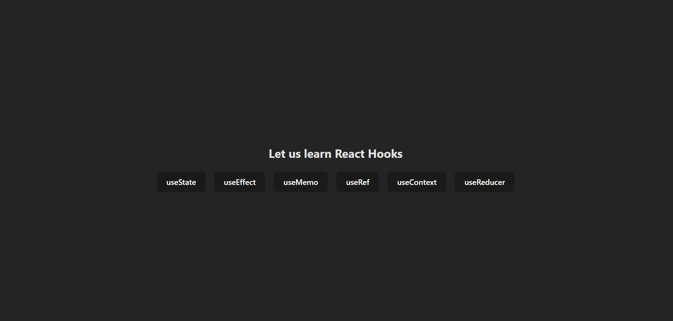
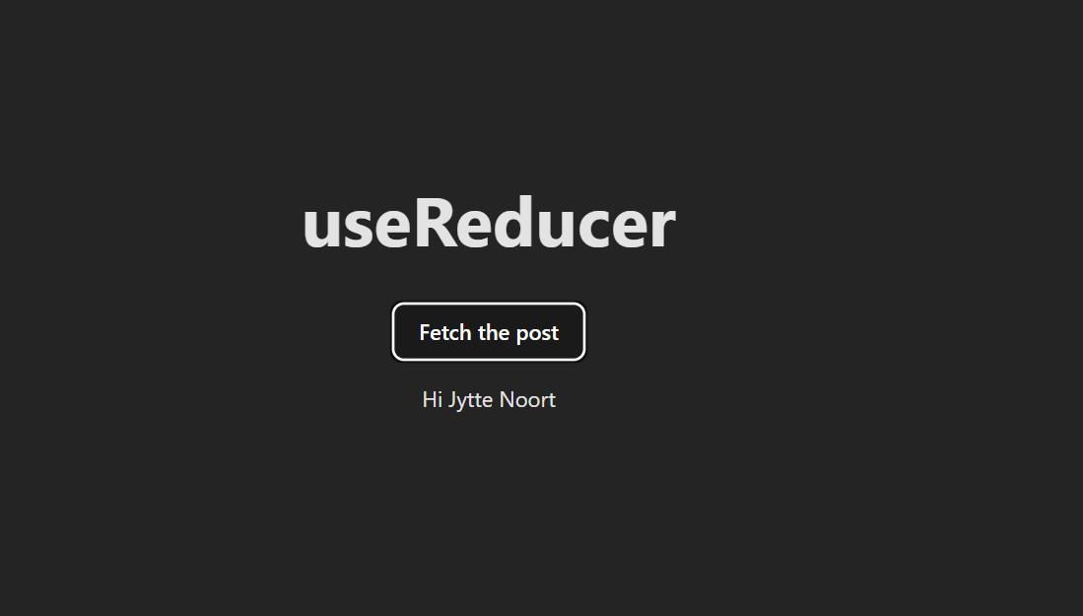

- useMemo

import { useState, useMemo } from "react";
import "../App.css";
function UseMemo() {
const [count, setCount] = useState(0);
const [darkTheme, setDarkTheme] = useState(false);
const squareResult = useMemo(() => {
delayFunction(count);
}, [count]);
const themeStyles = useMemo(() => {
return {
backgroundColor: darkTheme ? "blue" : "red",
color: darkTheme ? "red" : "blue",
};
}, [darkTheme]);

return (
<>
<div className="card">
<h1>useMemo</h1>
<label>
Number:{" "}
<input
type="number"
value={count}
onChange={(e) => setCount(parseInt(e.target.value))}
/>
</label>

<p>Square: {squareResult}</p>

<button onClick={() => setDarkTheme((prevTheme) => !prevTheme)}>
Change Theme
</button>
<p style={themeStyles}>Theme div</p>
</div>
</>
);
}

function delayFunction(n) {
for (let i = 0; i < 1000000000; i++);
return n * n;
}
export default UseMemo;

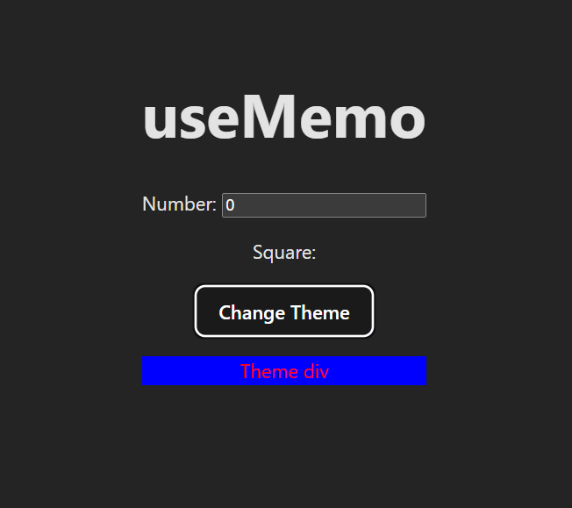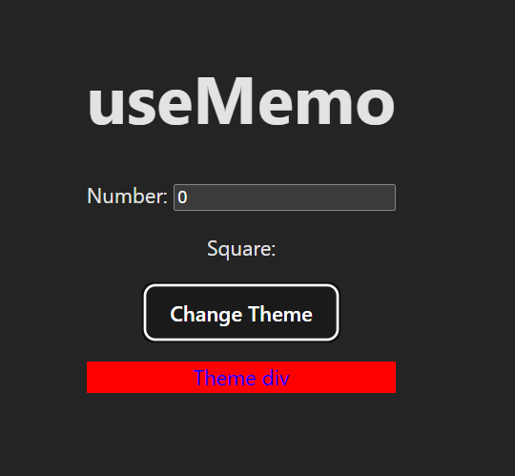

- useCallback

import { useState, useCallback } from "react";

var funccount = new Set();
const UseCallback = () => {
const [count, setCount] = useState(0);
const [number, setNumber] = useState(0);

const incrementCounter = useCallback(() => {
setCount(count + 1);
}, [count]);
const decrementCounter = useCallback(() => {
setCount(count - 1);
}, [count]);
const incrementNumber = useCallback(() => {
setNumber(number + 1);
}, [number]);

funccount.add(incrementCounter);
funccount.add(decrementCounter);
funccount.add(incrementNumber);
return (
<div className="card">
<h1>useCallback</h1>
<p>Count: {count}</p>
<p>Function Count: {funccount.size}</p>
<button onClick={incrementCounter}>Increase counter</button>
&nbsp;&nbsp;&nbsp;&nbsp;
<button onClick={decrementCounter}>Decrease Counter</button>
&nbsp;&nbsp;&nbsp;&nbsp;
<button onClick={incrementNumber}>Increase number</button>
</div>
);
};

export default UseCallback;

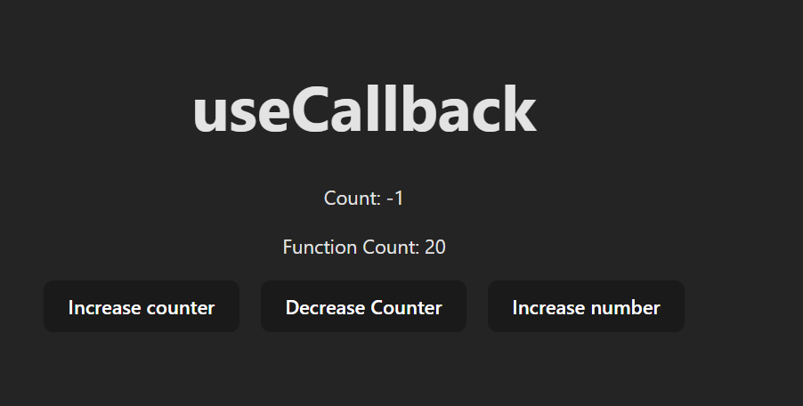

- useContext

import { useState, createContext, useContext } from "react";

const UserContext = createContext();

function UseContext() {
const [user] = useState("AWT Student");

return (
<UserContext.Provider value={user}>
<h2>{`Hello ${user}!`}</h2>
<Component2 />
</UserContext.Provider>
);
}

function Component2() {
return (
<>
<h2>Component 2</h2>
<Component3 />
</>
);
}

function Component3() {
return (
<>
<h2>Component 3</h2>
<Component4 />
</>
);
}

function Component4() {
return (
<>
<h2>Component 4</h2>
<Component5 />
</>
);
}

function Component5() {
const user = useContext(UserContext);
return (
<>
<h2>Component 5</h2>
<h2>{`Hello ${user} again!`}</h2>
</>
);
}
export default UseContext;

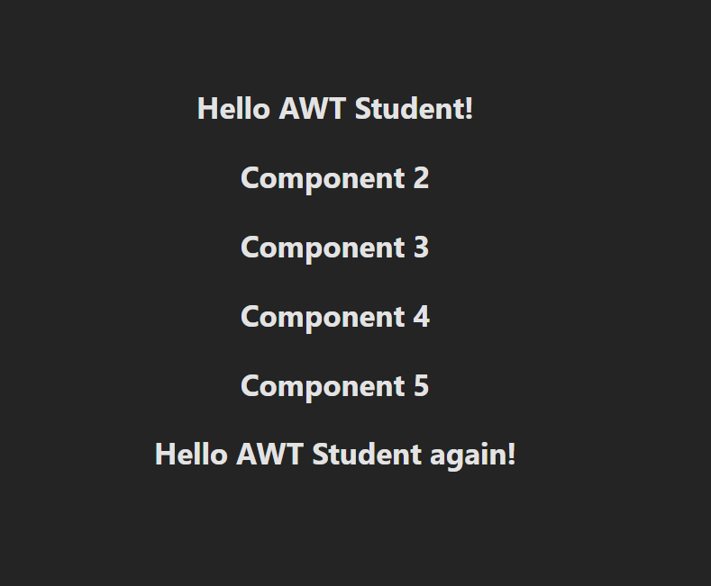

- useEffect

import { useEffect, useState } from "react";
import "../App.css";
function UseEffect() {
const [count, setCount] = useState(0);
const [numberProperty, setNumberProperty] = useState("");

useEffect(() => {
if (count % 2 === 0) {
setNumberProperty(`Even Number: ${count}`);
} else {
setNumberProperty(`Odd Number: ${count}`);
}
console.log("useEffect changed");
}, [count]);

return (
<>
<div className="card">
<h1>useEffect</h1>
<button onClick={() => setCount((count) => count + 1)}>
Click Me!
</button>
<p>{numberProperty}</p>
</div>
</>
);
}
export default UseEffect;

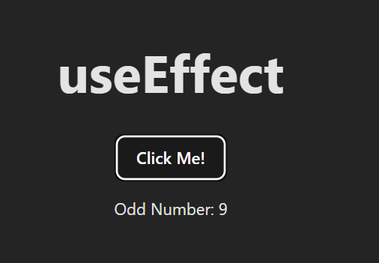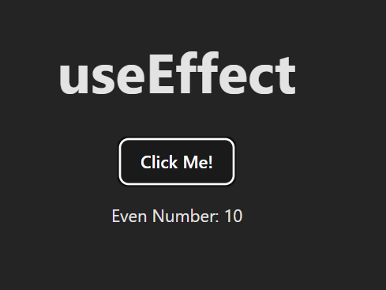

- Design a custom hook that helps you declare a default value of a component
Customhook.jsx
import useFetch from "./useFetch";
const Customhook = () => {
const data = useFetch("https://jsonplaceholder.typicode.com/todos");
return (
<div className="card">
<h1>Custom Hook</h1>
{data &&
data.map((item) => {
return <p key={item.id}>{item.title}</p>;
})}
</div>
);
};
export default Customhook;

useFetch.js
import { useState, useEffect } from "react";
const useFetch = (url) => {
const [data, setData] = useState(null);

useEffect(() => {
fetch(url)
.then((res) => res.json())
.then((data) => setData(data));
}, [url]);

return data;
};
export default useFetch;

